

Exploring the Determinants of Loan Approval and Loan Amount Decisions

By:- AMANI MAHROOF (COADDS232F - 033)
BACHELOR OF SCIENCE (HONS) DATA SCIENCE
NATIONAL INSTITUTE OF BUSINESS MANAGEMENT (NIBM)

Colombo, Sri Lanka.
Date of submission – 23rd of August 2024

“A Project Proposal submitted for the partial fulfillment of the requirements of Advanced Diploma in Data Science(Full time) Programme.”
Declaration

I hereby declare that the work presented in this project report was carried out independently by myself and have cited the work of others and given due reference diligently.

……………….
Amani Mahroof

……………….
Date

I certify that the above student carried out his/her project under my supervision and guidance.

………………..
W.M.S.G.D.C Wanigasekara

………………..
Date

Acknowledgement
I would like to express my deepest gratitude to all those who contributed to the successful completion of this project. First and foremost, my heartfelt thanks go to my Course Director and research supervisor, Ms. W.M.S.G.D.C. Wanigasekara, for her invaluable support, guidance, and encouragement throughout the entire process. Her insights and expertise have been instrumental in shaping this work.
I am also deeply thankful to Senior Lecturers Mr. Ashan Attunayake for his guidance and thoughtful advice during the project. His input was greatly appreciated and made a significant impact.
Lastly, I would like to extend my warmest thanks to my family and friends for their unwavering support, motivation, and encouragement throughout this journey. Their belief in me has been a source of strength and inspiration.

Executive summary

This research identifies the main factors that determine whether a loan gets approved by Dream Housing Finance and the amount that gets sanctioned. Various critical variables related to applicant income, coapplicant income, loan term, education, and credit history, among others, would be targeted in the research to which statistical techniques like Multiple Linear Regression, ANOVA, and Chi-square tests would be applied to deduce their effects.
The results have thrown up that applicant income and coapplicant income together with loan amount terms play an important role in the loan amount sanctioned. Similarly, educational level is highly related to the loan amount sanctioned and credit history has a high relation with approval or rejection. The findings point to the fact that financial and demographic factors are major concerns in loan approval.
The study concludes by recommending ways to improve decision-making in loan approvals, including greater transparency in credit history, the introduction of customized loan products, and financial literacy among customers. This would definitely help financial institutions like Dream Housing Finance smoothen their processes, reduce loan rejects, and enhance customer satisfaction.
This research provides salient lessons that could be used in optimizing loan approval decisions, enhancing operational efficiencies, and providing fuller clarity on the drivers of these financial outcomes.

Table of Contents
1. Introduction 1
1.1 Background 1
1.2 Research problem 1
1.3 Objective of the research 1
1.4 Research question 2
1.5 Scope of the research 2
1.6 Justification of the research 2
1.7 Limitations 3
1.8 Proposed Work Schedule 3
2. Literature review 3
2.1Introduction to the research theme 3
2.2Theoretical explanation about the Key Words in the Topic 4
2.3 Findings by other researchers 4
2.4 Research gap 6
2.5 Table for Variables, their definitions and sources 6
2.5 Chapter conclusion 8
3.Methodology 8
3.1 Introduction 8
3.2 Population, sample and Sampling technique 8
3.3Type of Data to be collected and data sources 9
3.4 Data collection tools and plan 9
3.5 Conceptual framework 9
3.6 Hypothesis 10
3.7 Operationalization Table (should contain Variable, Definition, Indicators, Measures,and References) 10
3.8 Methods of data analysis 14
4.Data Analysis 15
4.1 Data preprocessing 15
4.2 Data visualization for catergorical variables 17
4.3 Data Visualization for numerical variables 21
4.4 Findings and Interpretation 23
5.Discussion and Recommendation 26
5.1 Discussion 26
5.2 Recommendation 26
5.3 Conclusion 27
Appendices 29

Table of Figure

Figure 1 Structure of dataset 15
Figure 2 Deleting Null Values 16
Figure 3 Converting Data Types 16
Figure 4 Pie Chart for Gender 17
Figure 5 Barchart for Education 18
Figure 6 Stacked Barchart for Area 18
Figure 7 Pie Chart for employement 19
Figure 8 Bar Chart for marital status 20
Figure 9 Bar Chart for credit history 20
Figure 10 Summary Description for Numerical variables 21
Figure 11 Histogram for Applied Income 21
Figure 12 Histogram for Co applicant income 22
Figure 13 Box Plot to Loan Amount 23
Figure 14 Statistical Result of Multiple Linear regression 24
Figure 15 Result of ANOVA test 24
Figure 16 Result of Chi Square test 25

1. Introduction

1.1 Background

The modern financial world is all about understanding various factors affecting the sanctioning of loans, in order to improve various decision-making processes. Dream Housing Finance caters to diverse clientele across urban, semi-urban, and rural regions with a view to providing home loans. This research will be conducted about loan eligibility and the amount approved by analyzing data regarding customer loan applications.

These are the variables to be studied in this research: income, education, credit history, and loan term, in relation to loan approval and the amount disbursed. By looking at this, this research will draw on how Dream Housing Finance can understand their loan approval process better and improve decision-making to eventually arrive at a efficient practice.

1.2 Research problem

The problem statement is therefore developed to test and find the impact of applicant income, co-applicant income, loan term, educational level, and credit history on decisions about approving a loan amount and its grant at Dream Housing Finance. The purpose of this study, in fact, is to get useful inferences regarding the influence of these factors on loan approval through statistical methods such as Multiple Linear Regression, ANOVA, and Chi-Squared Test.

1.3 Objective of the research

- Objective: Investigate the Combined Effect of Applicant Income, Co-applicant Income, and Loan Term on Loan Amount Approved

- Objective: Determine the relationship between Educational Level and Loan Amount Approval

- Objective: Examine the Relationship Between Credit History and Loan Approval

1.4 Research question

- How do the applicant's income, co-applicant's income, and loan term collectively influence the amount of loan approved by the bank?
- Does the educational level of an applicant affect the loan amount approved by the bank?
- How does the applicant's credit history influence the loan approval status?

1.5 Scope of the research
The scope of this study is to analyze the interaction of financial and demographic factors such as applicant income, educational background, loan term, and credit history in arriving at a decision for loan approval or the amount of money lent at Dream Housing Finance. It will make use of statistical methods necessary to determine how the given factors influence loan eligibility decisions. These findings will provide further insight into the variables that control loan approval, but no predictive model was developed for automation. It is instead focused on providing valuable insight that may be useful in making future improvements in the loan approval process.

1.6 Justification of the research
This research is justified in view of the compelling need of the hour to build efficiencies in loan-sanctioning processes within the financial sector. Clearly, comprehending how financial and demographic variables such as income, education, loan term, and credit history affect loan eligibility will substantially raise the quality of decision-making and result in refined lending policies, eventually leading to increased customer satisfaction.

The proposed research will try to establish a relation between these factors and how they impact loan decisions. Though this study does not develop a predictive model for automation, important insight is achieved that could give basis to the design of such models in the future. Identifying key factors and their interactions will contribute to resource use optimization and increased precision and speed of loan decisions for mutual benefit to both the company and customers.

1.7 Limitations
The main limitation of this research is not being able to collect data on my own since the instruction is to use a secondary dataset. based on the data obtained to conduct this research study, statistical analysis is the only tool that can be used and the data obtained is subjected to these limitations.

1.8 Proposed Work Schedule
5th August 2024 – Started to find a dataset for the project.
8th August 2024 – Finalized the dataset.
8th August 2024 – Started working on proposal presentation.
16th August 2024 – Project Proposal Submission
22nd August 2024 – Proposal Presentation
Week 4th of September 2024 – Final Project Report Submission

2. Literature review

2.1Introduction to the research theme
With time and accuracy emerging as the cornerstones of today's financial world, dealing with diversity regarding urban, semi-urban, and rural markets in Dream Housing Finance calls for complexity in automation. The research is aimed at looking out for the factors that affects the status-allocation or rejection-of the loan applications and the amount being sanctioned. Attention will be given to the central variables: applicant income, co-applicant income, loan term, education level of applicant, and credit history.

It will study all these factors and their interaction to provide insight into how these factors affect the decisions of loan disbursement. Even though no automation models are developed in this study, results of this information are useful for developing better accuracy and efficiency of approval of loans. These insights will help to improvise decision-making practices and refine the loan approval systems at Dream Housing Finance, which will be beneficial both for the company and the customers.

2.2Theoretical explanation about the Key Words in the Topic
- Loan Approval: Approval of a loan is granted by the lending company when a lender needs to decide on acceptance or rejection of the loan application based on creditworthiness, income, and financial stability.

2. Loan Eligibility: It's the set of guidelines that determines who is eligible for the loan and who is not. Income, credit score, employment status, and other financial obligations come into play here.

3. Credit History: Information that pertains to a borrower's history regarding his or her borrowing, payment experience, and other forms of credit availed, which lenders use to appraise the risk of lending.

4. Loan Amount Decisioning: The process that determines how much a lender is willing to lend a borrower, which can be based on factors related to his income, credit history, and loan terms.

5. Data Analysis-Statistical: The process of collection, analysis, and interpretation of data to find patterns and relationships; here, applied to study the factors that determine the decision to approve/deny a loan and the amount to be sanctioned.

2.3 Findings by other researchers
01.This paper focuses on the factors affecting the housing loan approval decision by Binary Logit Regression and Random Forest models. Lenders became more cautious with increased nonperforming housing loans in the last two years, so applicants had to face increased uncertainty, too. In this study, 480 loan records with 12 variables have been analyzed in order to develop a predictive model for loan approval. The accuracy of the Binary Logit Regression model is 81.64%, and the region of the applicant and credit status of the applicant are significant factors that influence the loan approval. Random Forest model also pointed out Credit history, monthly income, and Loan term as important variables. These results hint that applicants are able to estimate their probabilities of loan approval based on some critical factors.

02.This paper examines the unique agricultural loan underwriting issues lenders encounter by querying financial institutions in Kansas and Indiana with a standardized fictitious agricultural loan application. The applications were uniform, except each had one distinguishing characteristic in one of the following areas of the borrower's character, his financial record-keeping, productive standing, Fair Isaac credit score, or credit risk. The lenders also provided selected information about themselves and their institution. In this regard, the Tobit models are utilized in the analysis of the data for the determination of the vital characteristics of borrowers and lenders which control the loan approval, while OLS models are used in the analysis of factors controlling interest rates for farm borrowers. The present study compares the agricultural lending practices between Kansas and Indiana by furnishing an insider's look into the agricultural lenders' decision-making processes.

03.This paper highlights the problems SMEs face in Malaysia, especially concerning finances, which they need to exist. Most SMEs lack access to this finance because of their collateral of very small value and failing to present good past financial records. The research tries to identify whether the factors such as management knowledge on business, collateral availability represented by CCRIS report, and borrowing capacity will influence the decision of bank officers to approve or reject loan application. This research uses a 2 x 2 x 3 experimental design and samples 63 bank officers in northern Peninsular Malaysia. The result shows that all three factors significantly influence loan approval decisions. The study recommends that SMEs should be well-prepared when seeking a loan by securing collateral, establishing good relationships with financial institutions, and maintaining healthy financial records. In addition, it is recommended that government agencies educate SMEs on how to prepare properly the documentation needed by such financial institutions.

04.This study identifies the critical factors that influence the decisions of loan granting in Egyptian banks from responses by 657 borrowers and 12 banks. Through SPSS, the loan amount was perceived to be influenced by three factors: collateral, income, and risk levels, while education, income, and age were the three influencers of loan terms. Experience, income, risk levels, reputation, and repayment ability, on the other hand, influence the decision on whether to grant the loan or not. The findings highlight implications both theoretically and managerially. Some of the keywords involved relate to loan amount, loan term, collateral, and reputation.

2.4 Research gap
While numerous studies have analyzed the factors influencing loan approval decisions using various models such as Binary Logit Regression, Random Forest, and Tobit models, there remains a gap in understanding the combined effects of applicant income, co-applicant income, loan term, educational level, and credit history on loan approval decisions specifically in the context of Dream Housing Finance. Previous research has primarily focused on individual factors, different lending environments, or varied borrower characteristics. However, a comprehensive analysis that integrates these factors using statistical methods such as Multiple Linear Regression, ANOVA, and Chi-Squared Test to assess their collective impact on loan approval decisions at Dream Housing Finance is lacking.

This study fills this gap by systematically investigating how these financial and demographic variables interact and affect loan approval and the amount sanctioned, offering specific insights into the decision-making process at Dream Housing Finance. The results will contribute to improving loan approval practices and policies in this organization, particularly in relation to understanding how these key factors influence the approval and disbursement of loans.

2.5 Table for Variables, their definitions and sources

Variables | Definition | Kaggle
Gender | The gender of the person (Male/Female) | Kaggle
Married | Marital status of the loan applicant | Kaggle
Dependents | Number of people dependent on the loan applicant | Kaggle
Education | Educational level of the loan applicant | Kaggle
Self Employed | Self-employment status of the loan applicant | Kaggle
Applicant Income | Income of the loan applicant | Kaggle
Co-applicant Income | The income of another individual involved in the loan application | Kaggle
Loan Amount | The money requested/selected by the loan applicant/bank | Kaggle
Term | It represents the maturity period that the applicant should pay back the loan. | Kaggle
Credit History | Applicant's History of borrowing and repayment | Kaggle
Area | The geographic location of the property for which the loan is being applied is situated | Kaggle
Status | Whether the bank or the financial institution approved or not for the loan. | Kaggle

2.5 Chapter conclusion
The literature review highlights that, in the realms of housing, agriculture, and SMEs, among others, there exist a few very important factors affecting loan approval decisions, namely income, education, and credit history. While there have been various previous studies on isolated factors using models like Binary Logit Regression, Random Forest, Tobit, and OLS, knowledge with respect to combined effects that these variables might bring out, especially at Dream Housing Finance, is lacking.

This research tries to fill this gap by applying Multiple Linear Regression, ANOVA, and the Chi-Squared Test in order to explain how all these factors combined influence loan approval and the amount disbursed. It is expected that the study will provide insight into theoretical and practical ways of enhancing the loan approval process.

3.Methodology

3.1 Introduction

In this chapter, the population and sample selected for this study shall be described along with the types of data to be collected and their sources. The tools used for data collection along with the data-set obtained shall form the core aspect of the discussions in this chapter. The chapter shall also outline the conceptual framework developed for this research along with the hypotheses tested. A subsequent operationalization table will cover variables, their definition, indicators, measures, and references. Lastly, the methods of data analysis are discussed, where the tools of ANOVA and Multiple Linear Regression are emphasized to ascertain the relationship of variables corresponding to each objective. This chapter, therefore, sets out to provide a clear and organized understanding of the methodology adopted in this research study into factors that influence loan amounts or 'yes'/'no' approval decisions.

3.2 Population, sample and Sampling technique
In a statistical research study, for any such study, a population analyzed refers to a collection of people holding characteristics that will be studied. The population for this study includes all loan applicants of different statuses. These include males and females from different income and educational levels. The sample applied includes loan applicants whose applications were studied and analzed to give results for this study. The diversity in this sample gives the findings a truer picture of how loan approval and amount are influenced by factors related to income and education.

3.3Type of Data to be collected and data sources
The data collected in this research is qualitative and quantitative in nature. It includes qualitative data in the form of categorical variables, which comprise education level, marital status, credit history, among others, and numerical variables such as applicant income, co-applicant income, and loan amount. Each of these qualitative and quantitative types of data illustrates how varied those factors are that influence loan approval and amount. The source of the data for this project is the loan approval dataset obtained from kaggle website.

3.4 Data collection tools and plan
The material for this research will be sourced from a dataset retrieved from Kaggle, a well-liked online community platform for data scientists and machine learning enthusiasts. This dataset would, therefore, constitute secondary data. It comprises a heterogeneous sample of 1,200 applicants and co-applicants who were assessed to get comprehensive details regarding loan approval processes. The dataset includes applicant and co-applicant income variables, educational level variables, and the terms of the loan. This sample size ensures that the data obtained is robust and reliable for the factors in the loan approval decisions to be duly analyzed. Data shall then be integrated, analyzed, and used to provide insight in detail on how income, education, and loan term affect the amount of loan approved.

3.5 Conceptual framework
Objective: Investigate the Combined Effect of Applicant Income, Co-applicant Income, and Loan Term on Loan Amount Approved
- Dependent Variable: Loan Amount (numerical)
- Independent Variables: Applicant Income, Co-applicant Income, Loan Term (numerical)

Objective: Determine the relationship between Educational Level and Loan Amount Approval
- Dependent Variable: Loan Amount (numerical)
- Independent Variable: Education (categorical)

Objective: Examine the Relationship Between Credit History and Loan Approval
- Dependent Variable: Loan Approval Status (categorical)
- Independent Variable: Credit History (categorical)

3.6 Hypothesis
I. Investigate the Combined Effect of Applicant Income, Co-applicant Income, and Loan Term on Loan Amount Approved
• Null Hypothesis: There is no significant linear relationship between Applicant Income, Co-applicant Income, Loan Term, and Loan Amount Approved.
• Alternative Hypothesis: There is a significant linear relationship between Applicant Income, Co-applicant Income, Loan Term, and Loan Amount Approved.

II. Determine the Relationship Between Educational Level and Loan Amount Approval
• Null Hypothesis: There are no significant differences in Loan Amount Approved across different levels of Educational Level.
• Alternative Hypothesis: There are significant differences in Loan Amount Approved across different levels of Educational Level.

III. Examine the Relationship Between Credit History and Loan Approval
• Null Hypothesis: There is no significant association between Credit History and Loan Approval Status.
• Alternative Hypothesis: There is a significant association between Credit History and Loan Approval Status.

3.7 Operationalization Table (should contain Variable, Definition, Indicators, Measures,and References)

variables | definition | indicator | measures | references
gender | The gender of the person (Male/Female) | male/female | categorical | kaggle
married | Marital status of the loan applicant | married/not married | categorical | kaggle
dependents | Number of people dependent on the loan applicant | count | numerical | kaggle
education | Educational level of the loan applicant | educated /not educated | categorical | kaggle
self employed | Self-employment status of the loan applicant | yes/no | categorical | kaggle
applicant income | Income of the loan applicant | amount | numerical | kaggle
co applicant income | The income of another individual involved in the loan application | amount | numerical | kaggle
loan amount | The money requested/selected by the loan applicant/bank | amount | numerical | kaggle
term | It represents the maturity period that the applicant should pay back the loan. | time in years | numerical | kaggle
credit history | Applicant's History of borrowing and repayment | yes /no | categorical | kaggle
area | The geographic location of the property for which the loan is being applied is situated | urban/semi urban/rural | categorical | kaggle
status | Whether the bank or the financial institution approved or not for the loan. |  | categorical | kaggle

3.8 Methods of data analysis

The data would then be tabulated into Python and R Studio. Inferential statistics shall include an application of Multiple Linear Regression, Chi-Squared Test, and the ANOVA Test. The following are the objectives with their respective statistical tests:

1. Test the Combined Effect of Applicant Income, Co-applicant Income, and Loan Term on Loan Amount Approved
Statistical Test: Multiple Linear Regression
Procedure: This will outline how the variables Applicant Income, Co-applicant Income, and Loan Term interactively influence Loan Amount Approved. A Multiple Linear Regression model would be used to establish the strength and direction of these various relationships.

2. Determine the Relationship Between Educational Level and Loan Amount Approval
Statistical Test: ANOVA Test
Methodology: In this regard, ANOVA will be applied to test whether there is a significant difference in Loan Amount Approved across different levels of Educational Level. This will provide an insight into how loan amounts approved are influenced based on educational qualifications.

3. Analyze the Relationship between Credit History and Loan Approval
Statistical Test: Chi-Squared Test
The Analysis will adopt the Chi-Squared Test, which shall be used in ascertaining the relation between Credit History and Loan Approval Status. This test shall verify if the different credit histories make a significantly different distribution of loan approval statuses.

These hypotheses will be tested in R Studio, and after testing, these hypotheses will be accepted or rejected for the null or the alternative hypothesis. Again, this will provide a view on applicant income, co-applicant income, loan term, educational level, and credit history with respect to the loan approval decisions.

4.Data Analysis

4.1 Data preprocessing
Data preprocessing is an important step in data analysis, used to prepare raw data through cleaning and structuring. After the importation of the dataset, we then changed the data type-character variables into factors and integer variables into numeric because these would help in handling both categorical and continuous data better. We then checked the types of data afterward to make sure all are successfully converted. The next step was checking for missing values; therefore, we removed such rows to retain data integrity. Such steps are necessary to prepare the dataset for appropriate analysis and modeling.

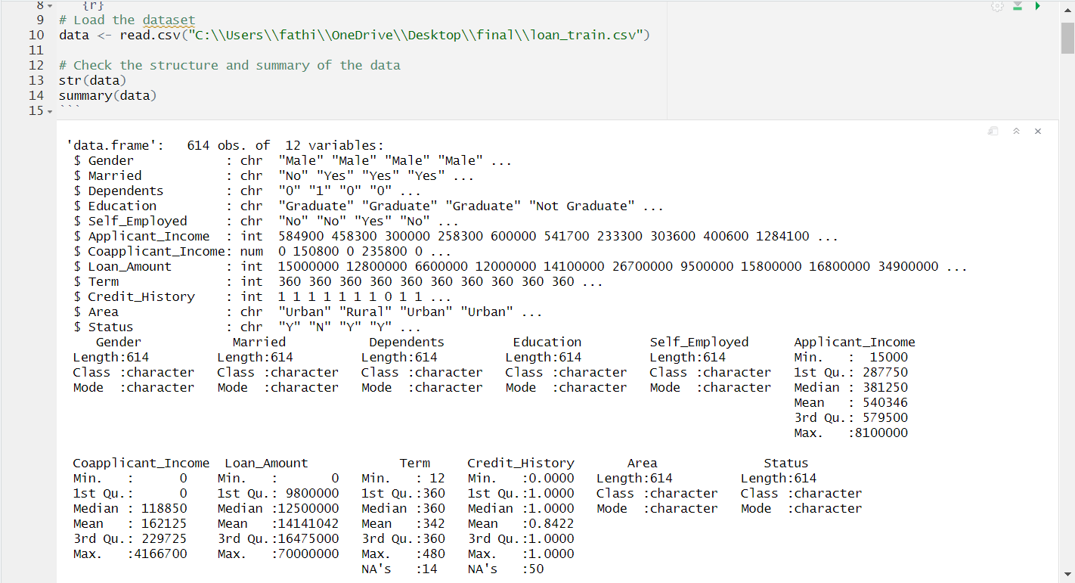
Figure 1 Structure of dataset

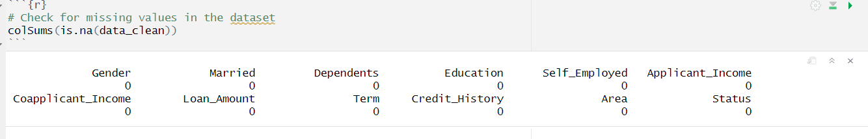
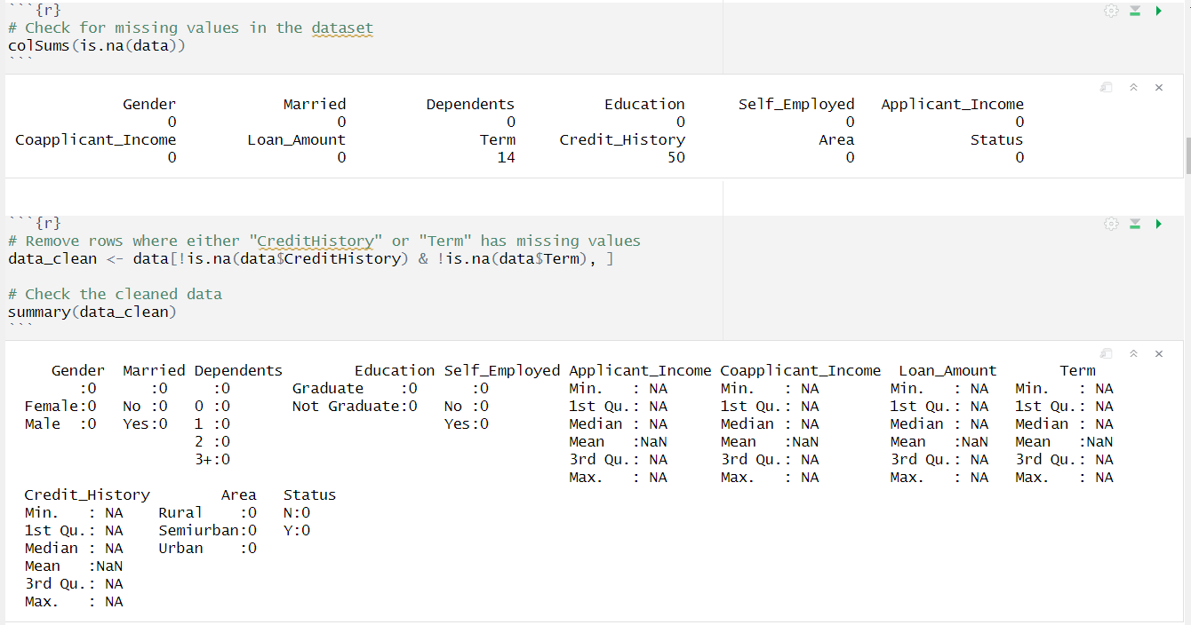
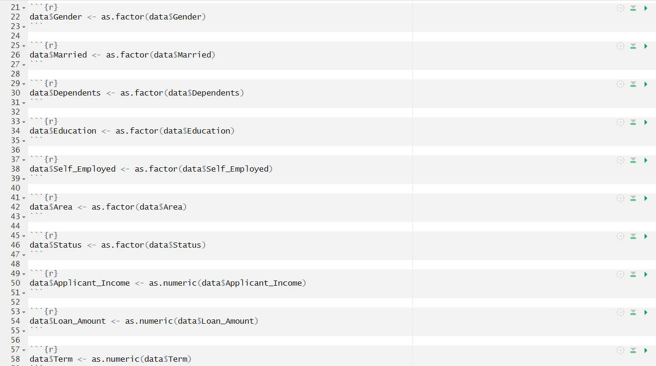
Figure 2 Deleting Null Values
Figure 3 Converting Data Types

4.2 Data visualization for catergorical variables

Gender

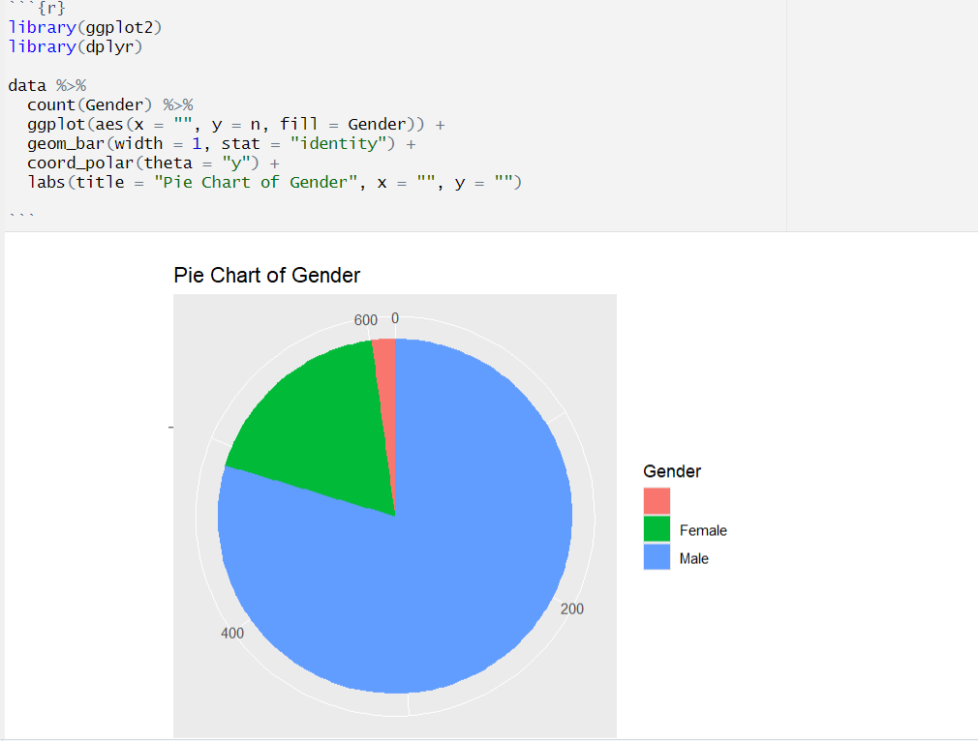
Figure 4 Pie Chart for Gender

This pie chart shows the distribution of gender in a dataset, where the large blue section is taken by the males and the smaller red section by females. Numerical labels on each wedge present the exact count for each category in gender, showing that the count of females is considerably lower compared to males. Such a visualization goes a long way in quickly assessing the gender ratio within the sampled population.

Education

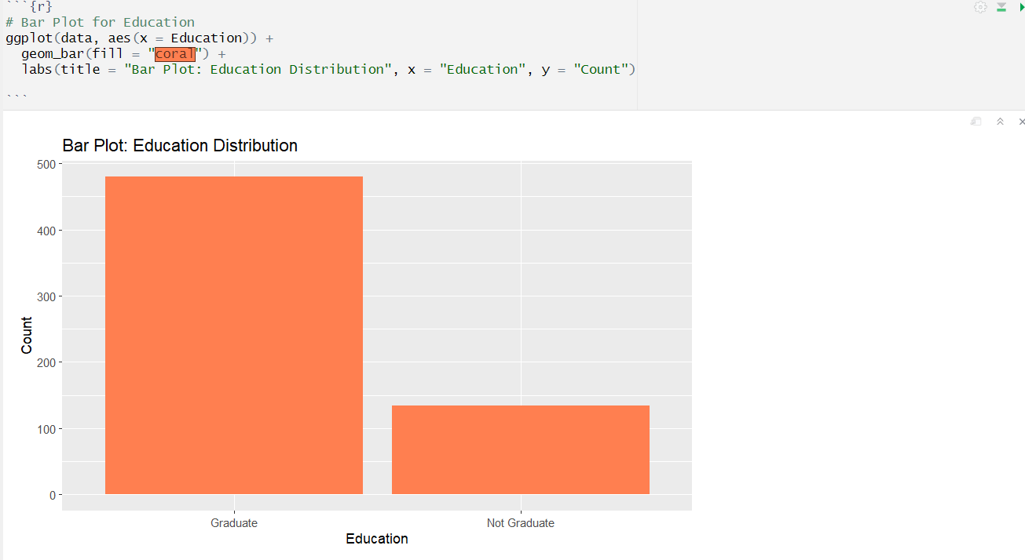
Figure 5 Barchart for Education

The above bar plot shows the distribution of education levels in this data set for two categories: "Graduate" and "Not Graduate." The height of the bars "Graduate" is considerably greater compared to "Not Graduate," indicating more graduates in this data set than non-graduates. This plot will help to get an idea of the educational composition of the population for this study.

Area
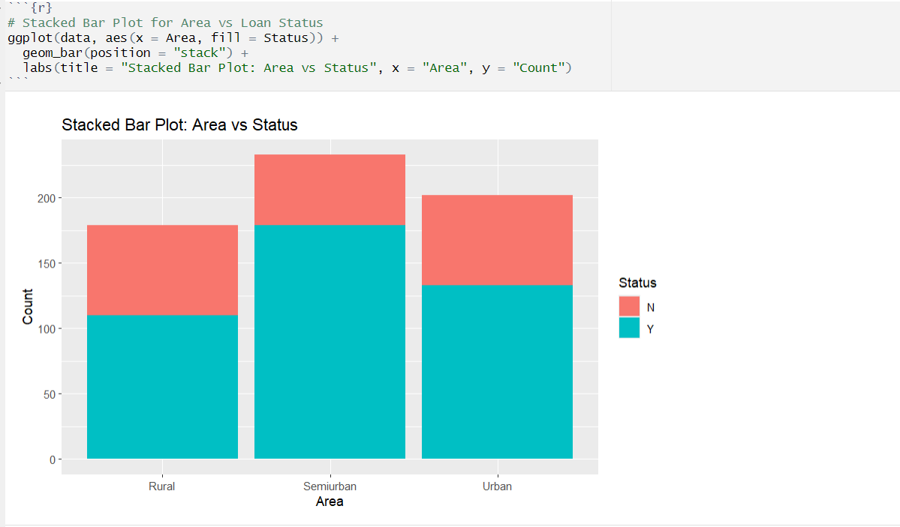
Figure 6 Stacked Barchart for Area
The stacked bar plot displays the distribution of a "Status" variable with categories "Y" and "N" across three geographic areas: Rural, Semiurban, and Urban. In each area, its bar is split into two segments colored differently for "Y" and "N," whose segment height represents the count in each category. The plot shows that in both Rural and Urban areas, the prevalence of "Y" is greater when compared to "N," while in Semi-urban it was almost evenly distributed between the two. The given visualization thus effectively analyzes and compares the distribution of statuses across different locations.

Self-employed

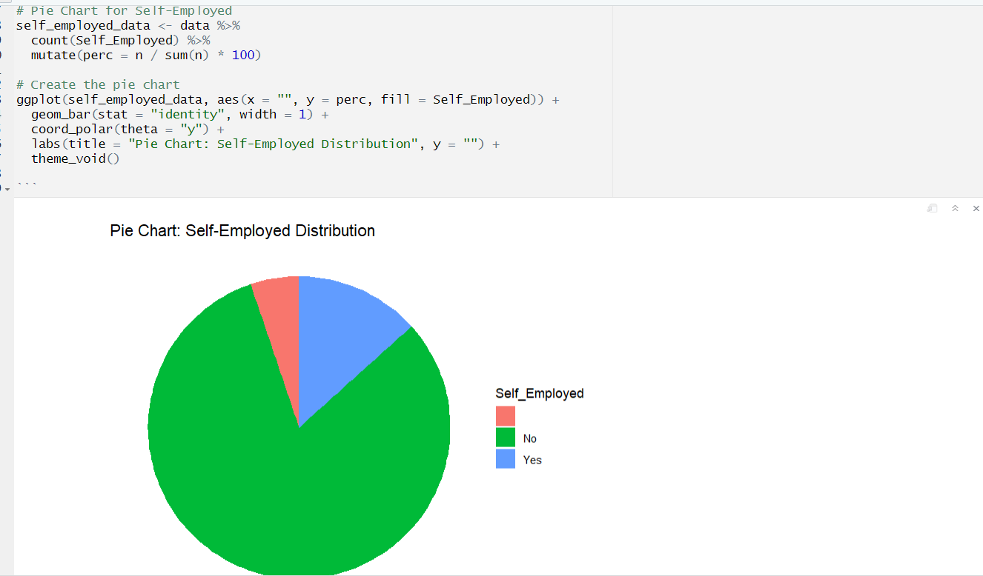
Figure 7 Pie Chart for employement

This pie chart shows the distribution of applicants who are self-employed versus those who are not. The chart helps in analyzing how many candidates among all applicants are self-employed, which can be helpful in the assessment of their financial risk for selecting the loan. A smaller share of self-employed candidates perhaps evidence that this category can be scrutinized more closely from the financial point of view.

Married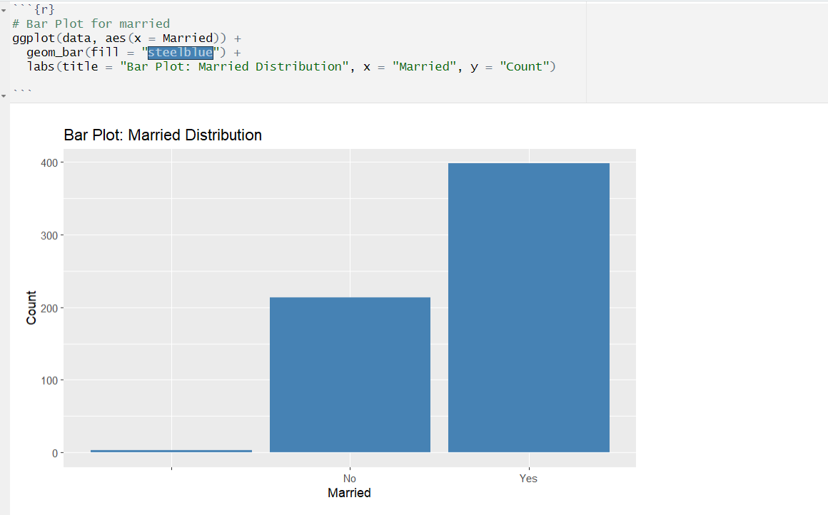
Figure 8 Bar Chart for marital status

The bar plot above depicts the number of married applicants versus the unmarried. If married applicants dominate, that may mean marital status could, in turn, impact a loan application trends since a married person stands to face dual incomes or stand at a better financial position.
Credit_History
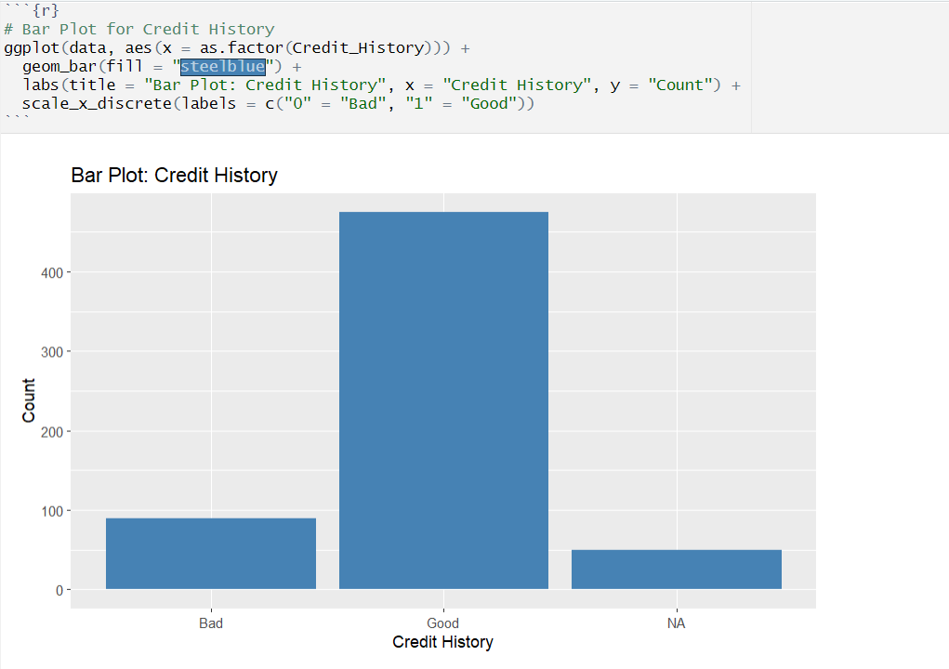
Figure 9 Bar Chart for credit history

This is bar plot that shows the relationship between an applicant's credit history and their subsequent loan approval status. The applicants who have a good credit history correspond to the higher proportion of loans approved, further solidifying how important creditworthiness is in decisions relating to the approval of loans.

4.3 Data Visualization for numerical variables

Descriptive statistics for Numerical Variables
Mean, Median, 1st Quartile, 3rd Quartile, Minimum and Maximum value of the Numerical Variable such as Applicant_Income, Coapplicant_Income, loan_amount and term are respectively as follows,

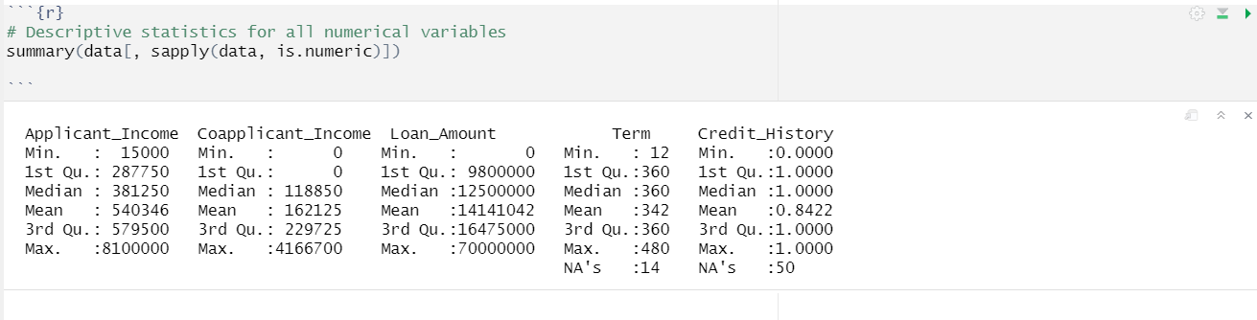
Figure 10 Summary Description for Numerical variables

Applicant_Income
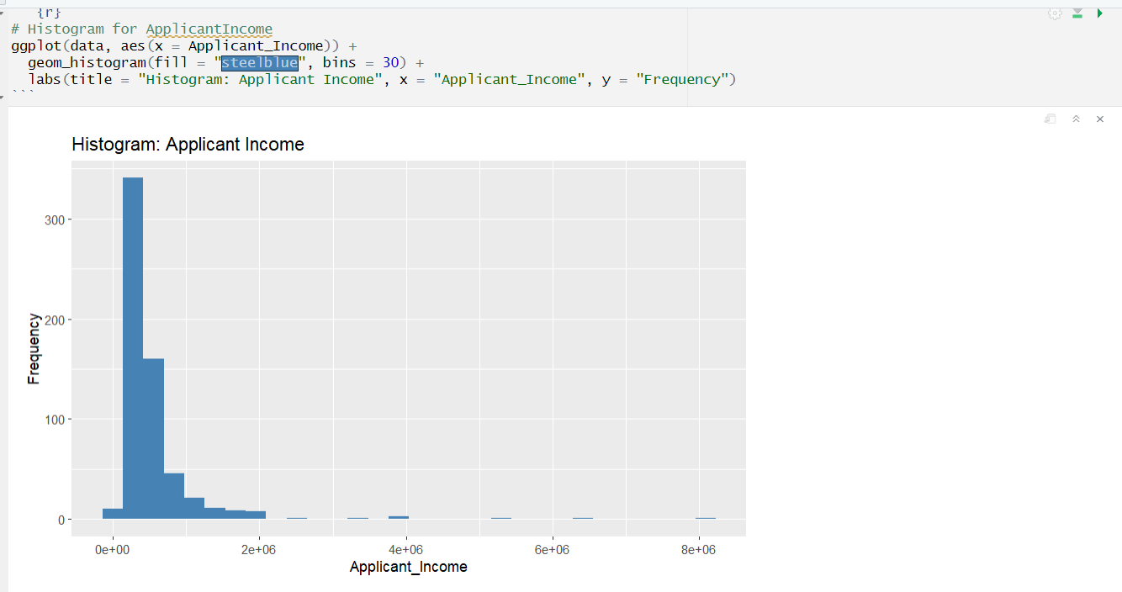
Figure 11 Histogram for Applied Income

This histogram represents the income distribution of applicants. It gives an indication of the range of individual incomes and the degree of skew or concentration of applicants around particular income levels. Perhaps the greatest proportion of applicants then falls into one bracket of income, which will affect their loan eligibility and approval.
Coapplicant_Income
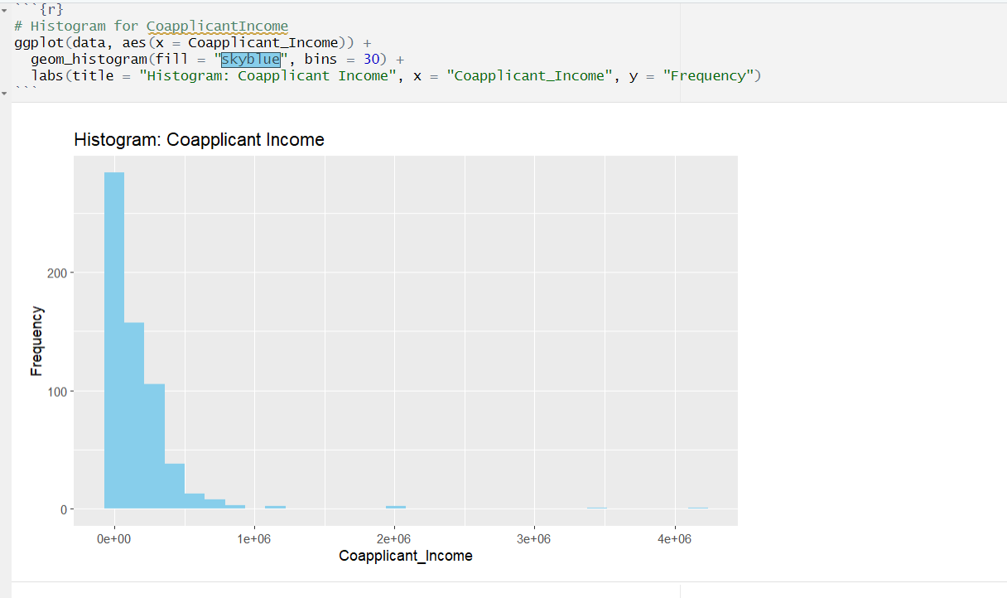
Figure 12 Histogram for Co applicant income
This above histogram shows the distribution of co-applicant income for all loan applications. We can see that most of the applicants lie in the lowest categories of income. This may indicate that their contribution towards the total household income is not very high. The right-skewed nature of the above distribution is indicative of their lower earning power compared to the primary applicants. The following analysis was performed to get a sense regarding co-applicant financials and how those affect loan approval as well as amounts.
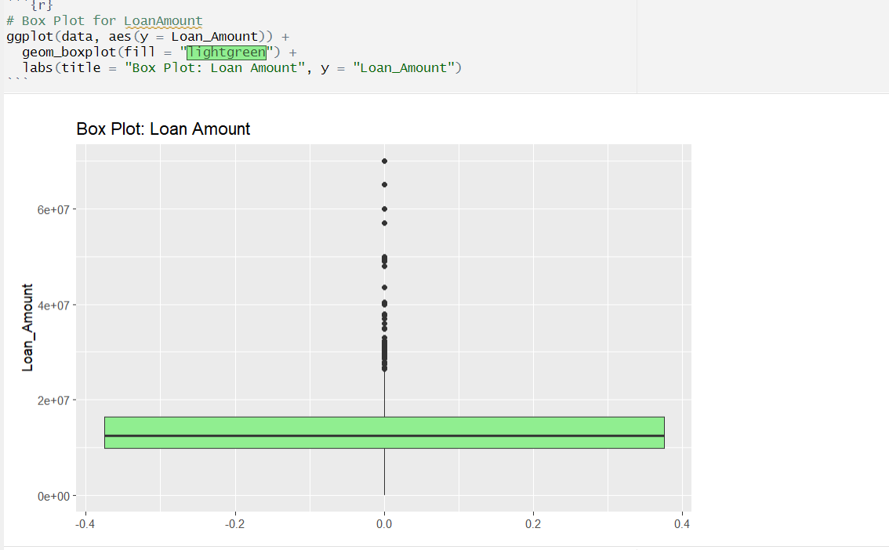
Loan_Amount
Figure 13 Box Plot to Loan Amount
In this box plot the median of the loan amount is on a point closer to the bottom of the box, meaning half of the loans are on the lowest ranges of the amounts. There are many outliers in the higher limit, indicating that even though most of the loans are of a lower amount, some loans are really very high.

4.4 Findings and Interpretation

All three objective of this research had been achieved after performing the three statistical tests in R-studio.
- Investigate the Combined Effect of Applicant Income, Co-applicant Income, and Loan Term on Loan Amount Approved
Multiple Linear Regression model
Dependent Variable: Loan Amount (numerical)
Independent Variables: Applicant Income, Co-applicant Income, Loan Term (numerical)

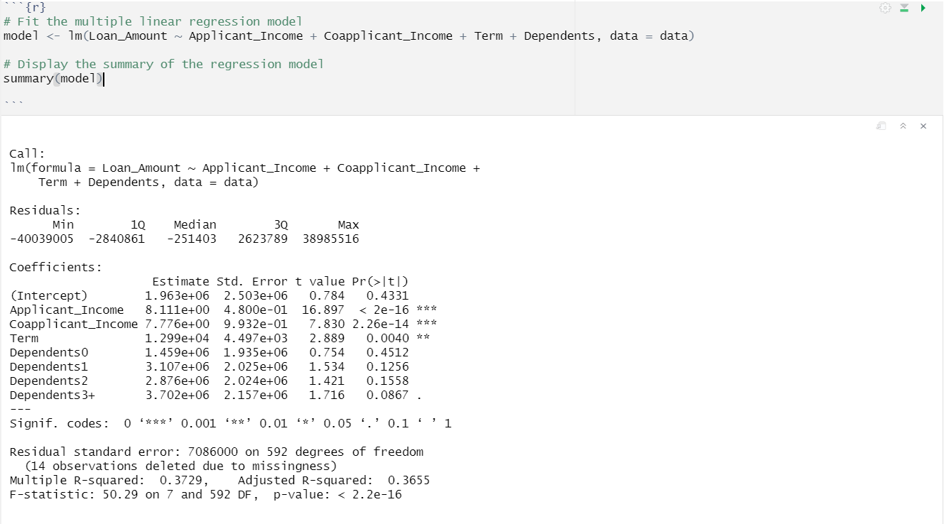
Figure 14 Statistical Result of Multiple Linear regression

From the results, we reject the null hypothesis and conclude that there is a statistically significant relationship between Applicant_Income, Coapplicant_Income, Term, Dependents and Loan_Amount. In addition, all three predictors are significant contributors of the model; applicant and coapplicant income being the strongest. The model explains a moderate part of the variation in the loan amount, but other factors might explain how the loan amounts vary not captured by the current model.

- Determine the relationship between Educational Level and Loan Amount Approval
ANOVA test
Dependent Variable: Loan Amount (numerical)
Independent Variable: Education (categorical)

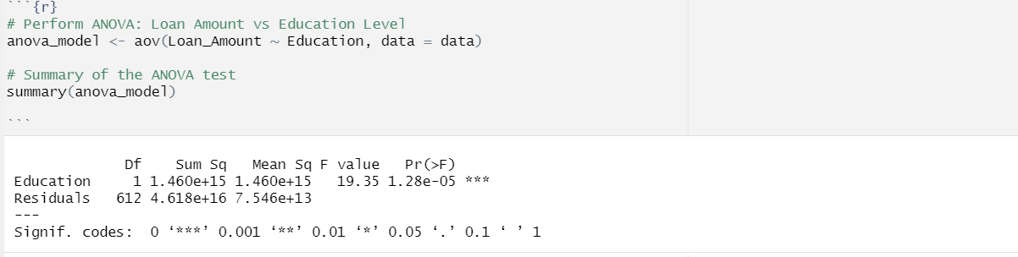
Figure 15 Result of ANOVA test

From the ANOVA results, it is observed that Education is a significant predictor of the dependent variable through a small p-value of 1.28e-05 with a high F-value of 19.35. Because the p-value is less than our significance level of 0.05, we reject the null hypothesis in favor of the alternative hypothesis, and we conclude that there is a statistically significant difference among the response variable across the Education levels.

- Examine the Relationship Between Credit History and Loan Approval
Chi-squared test
Dependent Variable: Loan Approval Status (categorical)
Independent Variable: Credit History (categorical)

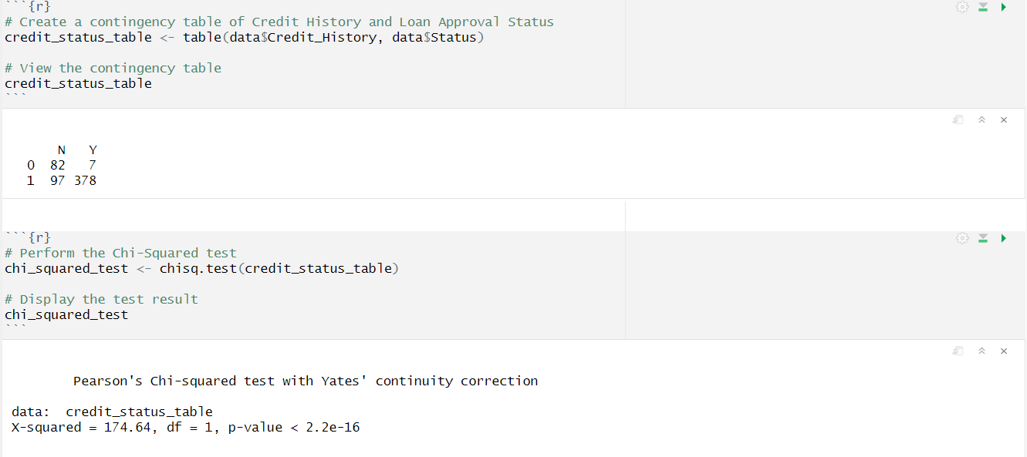
Figure 16 Result of Chi Square test

Since this p-value is much less than 0.05, we will reject the null hypothesis and will say that there exists a statistically significant association between two categorical variables in my credit_status_table. The Chi-Squared statistic of 174.64 indicates that the tested variables are strongly related to each other.

5.Discussion and Recommendation

5.1 Discussion
According to the three statistical tests of the objectives of this research of having the topic of exploring the determinants of loan approval and loan amount decisions indicate that the loan amount is significantly affected by applicant income, coapplicant income, and term of the loan. A Multiple Linear Regression Model was conducted to predict the relationship of Loan_Amount with independent variables Applicant_Income, Coapplicant_Income, and Term. Regression analysis also showed that all three predictors are significantly related to loan amount, therefore establishing a relationship between the mentioned factors. On running the ANOVA test, it was established that there is a difference in the amount lent out depending on the applicants' levels of education; this means that there is a minimum of one significant difference in means. The other important statistical analysis carried out was the Chi-square test; it was established that credit status is different for differing educational levels of applicants.
The findings of the present study are in agreement with earlier studies, wherein income and loan terms become important for determining the amount lent, and they provided detailed statistical confirmation. In fact, studying these relationships up to that level, the research also offers more insight into the relationships of income, coapplicant income, loan terms, and educational levels with loan amount and provides valuable input to lenders and policymakers in the credit industry.

5.2 Recommendation

Here are some recommendations for my study are follows:
- Enhance Credit History Transparency and Support Programs
Facilities and tools should be provided by the financial institutions regarding clear and timely feedback on an applicant's credit history and factors affecting their loan eligibility; free or discounted credit counseling facilities that can help applicants improve their credit score so that, on reapplication, chances are that they shall be found acceptable. Such initiative would increase customer confidence and reduce rejections on grounds of poor credit history.

- Introduce Tailored Loan Products Based on Applicant Profiles
Design specific loan products for targeted customer segments, such as low-income applicants or those with limited credit history. Special loans may be designed for self-employed people or applicants with non-traditional sources of income. In this way, by offering customized loan solutions, an institution such as Dream Housing Finance will increase its number of customers while reducing the rate of defaults since the product is matched to the financial realities of the applicant.

- Implement Financial Literacy and Loan Management Education Program
Such a financial institution as Dream Housing Finance should, therefore, provide financial education to the customers to improve financial literacy. With such educational programs, applicants will have an idea of a few of the basic factors that have a bearing on loan decisions like income, coapplicant income, loan term, and credit history. With such education, the customers shall understand the grounds for the decision of the loans so they may improve their creditworthiness in addition to making informed decisions on loan applications. This will result in fewer rejections, and indeed, the loan processing may achieve much more efficiency.

- Encourage Collaborative Loan Applications to Improve Eligibility
Promote awareness among possible borrowers that having a coapplicant-spouse or family member-will further enhance the likelihood of loan approval. Applicants may achieve eligibility for a larger amount or have better terms by aggregating their incomes or credit history, leading to increased approval rates with bettered customer satisfaction.

5.3 Conclusion

Income, loan term, education, and credit history are the important variables found to influence loan approval and also amount lent. With statistical analysis, one could have valuable insights into how these different variables impact decision-making at Dream Housing Finance.
Recommendations were made in the direction of empowering financial literacy, providing customized loan products, enhancing credit history support, and the use of predictive models. This would make operations at Dream Housing Finance easier, reduce the number of loan rejections, increase customer satisfaction, and thus ensure a smoother and more equitable loan approval process.

Appendices

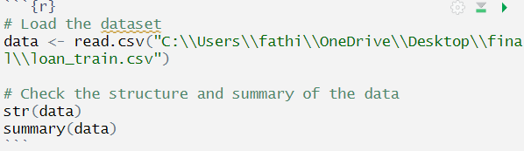

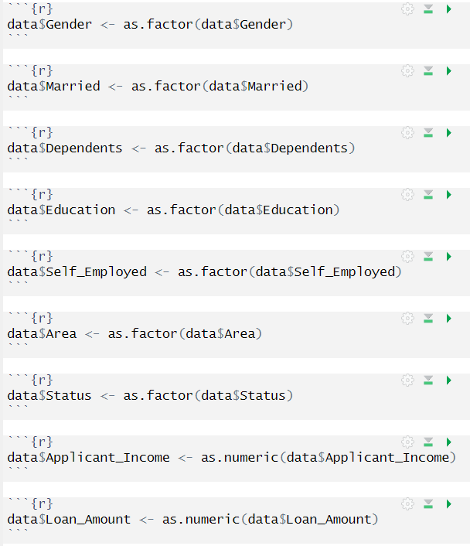

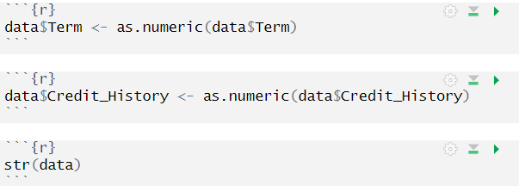

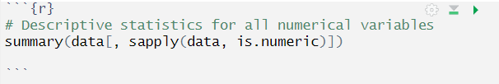

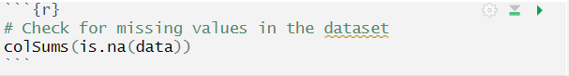

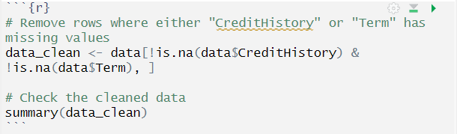

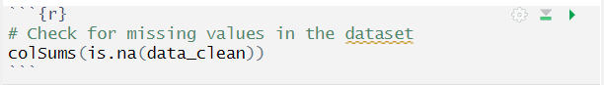

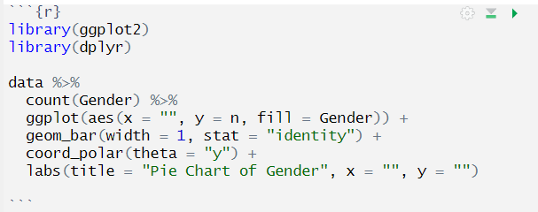

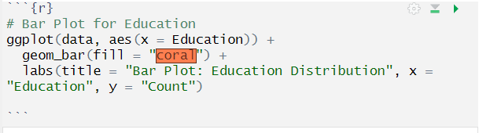

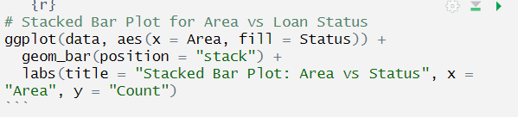

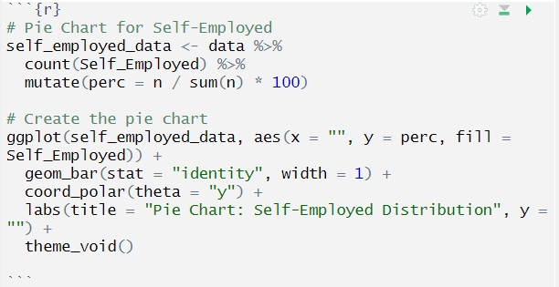

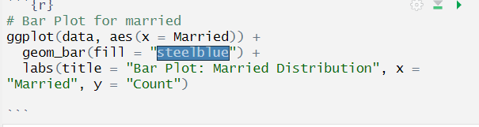

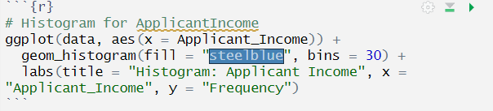

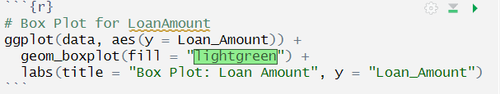

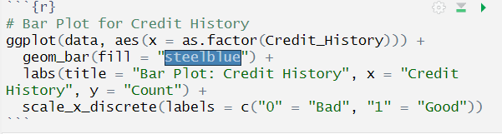

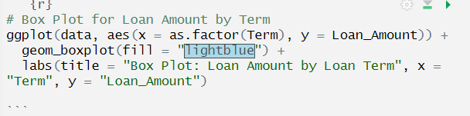

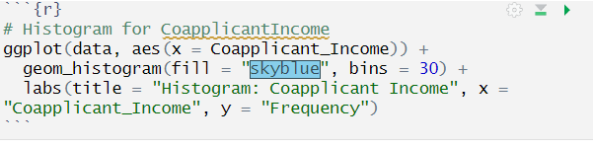

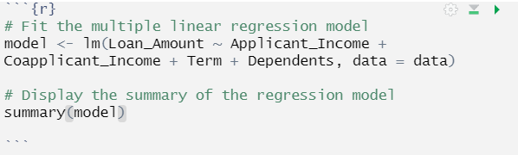

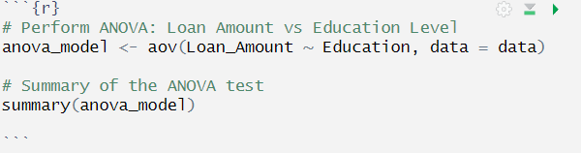

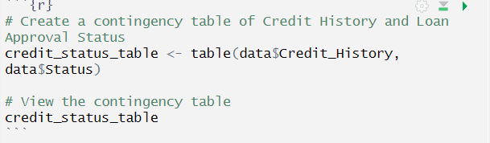

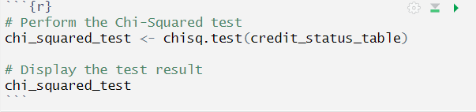

References
https://www.kaggle.com/datasets/rishikeshkonapure/home-loan-approval?select=loan_sanction_train.csv

https://d1wqtxts1xzle7.cloudfront.net/106206065/25-libre.pdf?1696435605=&response-content-disposition=inline%3B+filename%3DFactors_Influencing_Small_Medium_Enterpr.pdf&Expires=1725507732&Signature=LqMNGy9eQFQLOvVEdsIEDmZSaNYMMnzPsPZmBIMEbxd0H3xNaSXtLEr6Z8iCSD4EWbZy0hHYN5uwjsamxPmQ0Dhy6RMwxWMJDfoRac-TYaTtPDIVRRycTF2BElhHG87aKNplE-m5BXDHE7B5thJSDnLVq-gNEuBqdJ-OqOjyBGfKyEMkcFW7IPZkOapbdacK9V73iBP0izZZg7hZZlnipeWfoSkHhBJP5yFdBPpKQt2zflhG3nkGh828xsFAiNK~XKVTWwucQJFqD7~SYCTR0tXeNeoFuie2Vk-IaEO~5CSDXI2893fjcpNXXi7THXHg~wiVkHLbm-~84hn8nG2FLw__&Key-Pair-Id=APKAJLOHF5GGSLRBV4ZA

https://www.deanfrancispress.com/index.php/te/article/view/868

https://ageconsearch.umn.edu/record/28678/?v=pdf

https://utamu.ac.ug/wp-content/uploads/2024/02/Bank-Specific-Factors-Affecting-Loan-Performance.pdf

